


3D MRI Brain Tumor Segmentation

Rehab Hamdy | Marina Safwat | Alaa Mohsen
Computer science student at Helwan University | Computer science student at October 6 University | Computer Engineering student at Ain shams University

LinkedIn | LinkedIn | LinkedIn

Under the supervision of Eng/Mahmoud Talaat
AI engineer at ministry of Communications and Information Technology
Teaching Assistant at Zewail City

Abstract- Brain tumor diagnosis requires both precision and speed for effective treatment planning. Manual segmentation of tumors in MRI images is time-consuming and prone to human error, particularly when dealing with large datasets and the variability in tumor size, shape, and location. This paper presents a deep learning-based approach to automating brain tumor segmentation and classification. We employed ResNet-50 for tumor classification and three distinct architectures—U-Net, ResUNet, and VGG16—for the segmentation task. Our models were trained on a dataset of 4,000 MRI scans annotated with tumor regions. The results indicate that ResUNet provided the highest performance in segmentation with a 99.81% test accuracy, outperforming the other models in terms of Dice score and Intersection over Union (IoU). This work demonstrates the potential of automated segmentation tools to significantly improve the efficiency and accuracy of brain tumor detection, offering enhanced patient outcomes.

I. INTRODUCTION

Brain tumors are among the most serious and life-threatening conditions, and their early detection and precise localization are critical for timely diagnosis and treatment. Medical imaging, particularly Magnetic Resonance Imaging (MRI), plays a pivotal role in visualizing brain structures and identifying abnormalities. However, the manual segmentation of brain tumors from MRI images is a time-consuming, resource-intensive task that requires expert knowledge and is subject to human error. This process is particularly challenging when handling large datasets, where the variability in tumor appearance—such as differences in size, shape, and location—complicates the analysis further.

In response to these challenges, automated methods for brain tumor segmentation using deep learning have emerged as powerful alternatives. Deep learning models, especially convolutional neural networks (CNNs), have demonstrated significant potential in automating complex tasks in medical imaging by learning to detect patterns and features directly from data. This eliminates the need for manual feature engineering and helps achieve greater accuracy and efficiency.

Our research aims to develop an advanced deep learning system for the automated classification and segmentation of brain tumors from MRI images. To achieve this, we utilized a combination of well-established architecture. For classification, we employed ResNet (Residual Network), a widely recognized deep neural network model that excels in identifying patterns in complex image data. For the segmentation task, we explored multiple architectures, including U-Net, ResU-Net, and VGG, each tailored to capture the intricate details of brain tumor regions.

The U-Net architecture, with its encoder-decoder structure, is particularly suited for medical image segmentation, as it captures both high-level and low-level features while preserving spatial resolution through its skip connections. ResU-Net, an extension of U-Net, incorporates residual connections that help the model maintain performance in deeper networks, reducing the risk of vanishing gradients and improving segmentation accuracy. VGG, known for its strong feature extraction capabilities, was also incorporated into our segmentation pipeline to compare performance across different network designs.

The primary goal of this work is to create a robust deep learning-based solution that can automatically and accurately identify and segment brain tumors, thus improving the efficiency of the diagnostic process. To achieve this, we first acquired a dataset of brain MRI scans that were manually annotated with tumor regions. The data was preprocessed through normalization and augmentation techniques to enhance the model's generalization ability, including transformations such as rotations and flips. This step ensured that the model could handle the variability present in real-world MRI data.

The classification model, based on ResNet, was trained to detect the presence or absence of tumors in MRI images. Meanwhile, for segmentation, U-Net, ResU-Net, and VGG models were employed to predict the exact location and shape of the tumor in each image. The segmentation models were trained using Dice Loss, a metric commonly used in medical image analysis to optimize the overlap between the predicted segmentation and the ground truth tumor masks.

After the training phase, the models were evaluated on a separate test dataset using several performance metrics, including Dice score and Intersection over Union (IoU), to assess the accuracy of the segmentation models. For the classification model, metrics like accuracy, precision, recall, and confusion matrices were used to analyze its ability to correctly identify the presence or absence of tumors.

The significance of this research lies in its potential to transform the current approach to brain tumor diagnosis. Manual segmentation is not only labor-intensive but also subject to variability between human experts. By automating the segmentation process, we reduce the time required for analysis and ensure consistency and accuracy across different cases. Automated systems like the one developed in this study can significantly aid medical professionals in making faster, more reliable diagnoses and in planning appropriate treatment strategies, such as surgery, radiotherapy, or chemotherapy.

In conclusion, our study presents a deep learning-based framework for the classification and segmentation of brain tumors using MRI images. The use of ResNet for classification and U-Net, ResU-Net, and VGG for segmentation has allowed us to develop a highly effective solution that addresses the inherent challenges of brain tumor analysis. Our results demonstrate the capability of deep learning models to accurately detect and segment tumors, paving the way for future integration of these models into clinical workflows, ultimately improving patient outcomes through early and accurate diagnosis. Future work will focus on further optimizing these models and extending their applicability to a broader range of medical imaging tasks.

II. Problem Statement

The manual segmentation of brain tumors from MRI scans is a time-consuming process, often requiring expert radiologists. It is prone to human error and inconsistencies, especially in the presence of large amounts of data. Accurate and automated segmentation is essential to facilitate effective diagnosis and treatment planning. The primary challenges include:

- Manual Segmentation: Time-consuming, requires expert knowledge, and is prone to error.
- Tumor Variability: MRI scans show variations in tumor size, shape, and contrast.
- Automation: The need for efficient and consistent segmentation and classification across different MRI images.

III. Literature Review

Paper Title | Method Used | Accuracy Mertic
Brain Tumor Segmentation from Optimal MRI Slices Using a Lightweight U-Net | Lightweight U-Net | ~86% DSC
U-Net: Convolutional Networks for Biomedical Image Segmentation | U-Net (Fully Convolutional Networks) | ~85% Dice Score
Brain Tumor Segmentation with Deep Neural Networks | Two-phase Convolutional Neural Networks (CNN) | ~86% Dice Score
ResNet-based Deep Learning for Brain Tumor Segmentation | ResNet-based Deep Learning | ~87% Dice Score
nnU-Net: A Self-configuring Method for Deep Learning-based Biomedical Image Segmentation | nnU-Net | ~90% Dice Score

IV. Proposed Approach & Methodology

- Data Acquisition
The dataset consists of 4,000 MRI brain scans, each manually annotated to indicate tumor regions. The data was divided into 72% training, 18% validation, and 10% testing. MRI images were resized to 256x256 pixels and augmented with transformations such as rotations and flips to improve model generalization.

- Preprocessing
The MRI images were normalized and binarized. For segmentation, both the images and their corresponding tumor masks were processed using data augmentation techniques. These preprocessing steps aimed to ensure that the data was well-prepared for the training phase.

- Model Selection
- ResNet-50 was chosen for tumor classification. Its use of skip connections helps to overcome the vanishing gradient problem, making it ideal for complex classification tasks.
- U-Net, ResUNet, and VGG16-UNet were chosen for tumor segmentation. Each model was selected based on its strengths in feature extraction, spatial preservation, and generalization to biomedical tasks.

- Model Training
Models were trained using Dice Loss for segmentation and Categorical Cross Entropy for classification. The Adam optimizer was used for efficient gradient descent. Training was conducted over 50 epochs with a batch size of 32.

- Model Evaluation
The models were evaluated using performance metrics such as the Dice score, Intersection over Union (IoU), and test accuracy. Classification results were analyzed using a confusion matrix, while segmentation accuracy was measured using IoU and Dice score.

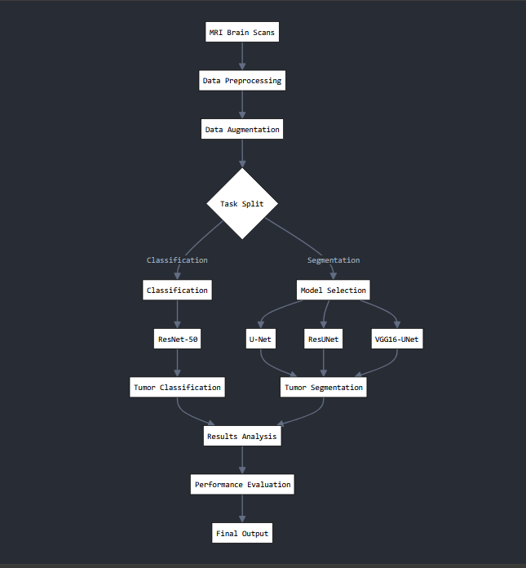Fig. 1: Pipeline for MRI brain tumor classification and segmentation. The process includes data preprocessing, augmentation, task split into classification (ResNet-50) and segmentation (U-Net, ResUNet, VGG16-UNet), followed by results analysis, performance evaluation, and final output.

V. Results

- ResNet-50 achieved a classification accuracy of 95.5%, effectively distinguishing between MRI scans with and without tumors.
- U-Net achieved an IoU score of 87% and a Dice score of 86.5% for tumor segmentation.
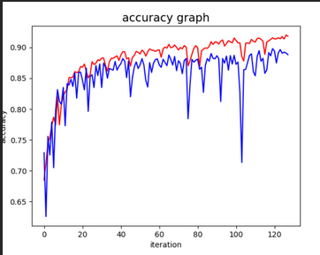

- ResUNet outperformed the other models, achieving a test accuracy of 99.81%, with the highest Dice score
and IoU.

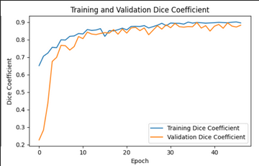

- VGG16-UNet showed a 99.79% test accuracy, performing well but slightly behind ResUNet in segmentation tasks.
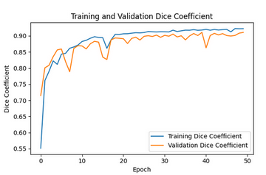

VI. Discussion

The results indicate that ResUNet was the most effective architecture for brain tumor segmentation, outperforming U-Net and VGG16 in terms of Dice score and IoU. ResUNet’s incorporation of residual connections allows for better feature extraction, particularly in complex medical images like MRI scans. U-Net, while a strong baseline, showed lower performance compared to ResUNet, likely due to the lack of residual connections, which are critical for deeper models.

ResNet-50 was highly effective for classification tasks, further supporting the use of deep learning for tumor detection. The results suggest that incorporating advanced architectures such as ResUNet can significantly improve the accuracy of automated tumor segmentation.

VII. Conclusion

In this study, we developed and evaluated a deep learning-based system for automated brain tumor segmentation and classification. By comparing multiple models—ResNet-50 for classification, and U-Net, ResUNet, and VGG16 for segmentation—we found that ResUNet delivered the best performance, achieving high accuracy and segmentation precision.

Automating brain tumor segmentation is a critical step towards improving diagnosis efficiency and accuracy in clinical settings. The use of deep learning architectures offers promising results and the potential for further optimization in medical imaging tasks. Future work will focus on refining these models, optimizing them for real-time applications, and integrating them into clinical workflows.

VIII. Future Work

Future research will explore the application of the current 3D MRI segmentation framework on larger datasets to improve model robustness and generalizability. Scaling up to tens of thousands of images from diverse sources could better capture tumor heterogeneity and enhance performance across different patient populations. Additionally, we aim to optimize computational efficiency, potentially incorporating distributed training or model compression techniques to handle larger data volumes while reducing training time and resource consumption. Incorporating post-segmentation tasks, such as tumor growth prediction or survival analysis, could also provide valuable clinical insights.

IX. REFERENCES

1. Ronneberger, O., et al. (2015). "U-Net: Convolutional Networks for Biomedical Image Segmentation." BRATS 2013.
2. Zhao, X., et al. (2019). "ResNet-based Deep Learning for Brain Tumor Segmentation." BRATS 2017.
3. Isensee, F., et al. (2021). "nnU-Net: A Self-configuring Method for Deep Learning-based Biomedical Image Segmentation." BRATS 2018.
4. Ovalle-Magallanes, E., et al. (2024). "Brain Tumor Segmentation from Optimal MRI Slices Using a Lightweight U-Net." BRATS 2017-2021.
5- Clough, J.R., et al. (2022). "A Dataset and Architecture for Benchmarking Robustness in Biomedical Image Segmentation." Medical Image Computing and Computer-Assisted Intervention (MICCAI).
6-Zheng, Y., et al. (2020). "3D Multi-modal MRI Brain Tumor Segmentation using Hybrid Networks." BRATS Challenge 2020

